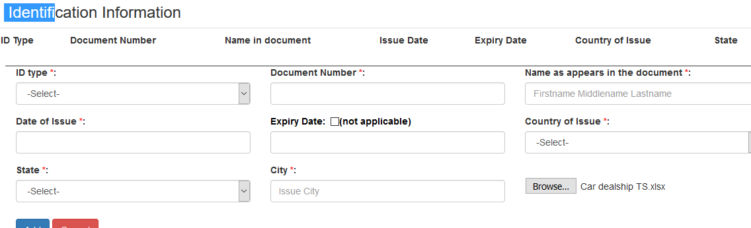

User is able to save an excel file with an extension .xlxs. An error message should pop-up “User is allowed to save files with extension .jpg, .gif, .png, .jpeg only”. Also when user is trying to save a .jpg file error message pops up